The Perception Gap: How BLS Headline Metrics Misrepresent the American Labor Market

Eli C. Loft
University of Tennessee at Chattanooga
CPSC 4530: Data Visualization and Exploration
Dr. Yu Liang
May 3, 2026
YouTube Video: [your link here]
Dataset Sources:
Dataset 1: BLS Employment Situation Data, accessed via FRED API https://fred.stlouisfed.org
Dataset 2: Federal Reserve and Census Bureau Monetary and Income Data,
accessed via FRED API https://fred.stlouisfed.org
Dataset 3: BLS Annual Benchmark Revision Records https://www.bls.gov/web/empsit/cesnaicsrev.htm

The Perception Gap: How BLS Headline Metrics Misrepresent the American Labor Market
The Bureau of Labor Statistics produces arguably the most important statistic regarding the state of the U.S. economy once a month. The nonfarm payroll count determines bond yields, Federal Reserve policy, and electoral narratives. According to the Bureau of Labor Statistics, the job market is continuously expanding. Despite this, consumer sentiment hit its lowest point since the data had started being collected, beating out the heights of COVID, the 2008 global financial crisis and the oil shock of the late 1970s (University of Michigan, 2025) and job posting is declining across all sectors of the economy (Indeed Hiring Lab, 2025). Jeff Bezos stated in a 2024 interview "When the data and the anecdotes disagree, the anecdotes are usually right. It's usually not that the data is being miscollected. It's usually that you're not measuring the right thing" (Fridman, 2024). This report proves that despite the nonfarm payroll numbers going up, the labor force has contracted by hundreds of thousands of workers in single months, prime age employment participation is still below the pre-pandemic baseline, and the gap between the unemployment numbers that show up in the headlines and the broader measures of labor market distress continues to widen to unsustainable levels.
This report gives a detailed analysis over the emerging divergence across four interconnected dimensions. First, the BLS uses a household and an establishment survey to measure the same labor market implying there should be a strong correlation between results. However, there is a growing narrative contradiction post-COVID. Second, they publish six different metrics of unemployment (U1-U6), where U3 contains only people who are jobless, actively looking and currently available to work and U6 contains a wider spectrum, also including recently discouraged workers and part time workers who cannot find a full-time position. U3 is the number that gets reported to headlines, while U6 is ultimately a better measurement of labor underutilization with a floor of discouraged workers dropping out of U6 at twelve months. Third, this report compares the monetary expansion of quantitative easing in relation to the stagnation of the median wages. The money is expected to trickle down into median wages despite only spiking asset prices, stock prices and real-estate prices, with the most recent surplus liquidity funneled into artificial intelligence development, ironically driving unemployment up. Fourth, this report examines the record of clustered overstated revisions correlating heavily with financial downturns.
The domain of this report lies in labor economics and monetary policy, with an emphasis on deviation of officially released statistics from economic reality and the validity of the measurement to acquire said statistics. The visualizations were created using publicly available data from the Federal Reserve Bank of St. Louis FRED database and BLS benchmark revision press releases. The analytical framework used draws on rhetorical visualization theory, specifically the work of Prantl et al. (2026) on pathos and aesthetic design in data visualization, and Lin et al. (2026) on visual rhetoric and persuasive cartography, to create charts that emphasize the claim.

Dataset Description
Dataset 1: BLS Employment Situation Data. Employment situation data produced by the Bureau of Labor Statistics accessed through the Federal Reserve Bank of St. Louis FRED API via the fredapi Python library. The dataset contains seven series that are summarized in Table 1 that range from January 2006 through March 2026. The start date was extended to 2006 rather than 2010 to capture the 2008 financial crisis to provide a fair comparison to a time with a similar divergence in labor market conditions. All series operate on a monthly frequency providing 243 observations across the seven series. This dataset provides the primary data for Visualizations 1 and 2. It establishes the divergence between the establishment and household survey results and the gap between headline and broad unemployment measures.

Table 1. BLS Employment Situation Series (Dataset 1)
Series ID | Description
PAYEMS | Nonfarm payrolls, establishment survey
CE16OV | Civilian employment level, household survey (substituted for LNS12000000  due to API unavailability; equivalent series)
UNRATE | U-3 headline unemployment rate
U6RATE | U-6 broad unemployment rate
CIVPART | Civilian labor force participation rate
LNS12300060 | Prime-age employment-population ratio
CLF16OV | Civilian labor force level (used to convert percentages to absolute worker  counts)

Dataset 2: Federal Reserve and Census Bureau Monetary and Income Data. This dataset covers Monetary policy and income data produced by the Federal Reserve Board and the U.S. Census Bureau accessed through the Federal Reserve Bank of St. Louis FRED API via the fredapi Python library. The dataset contains four series that are summarized in Table 2 that range from January 2010 through March 2026 as well for monetary series and 2010 through 2023 for the annual income series. All four series were normalized to an index value of 100 at January 2010 to allow for proportional growth rates to be compared on the same axes. WALCL operates on a weekly frequency while the remaining series are monthly, and MEPAINUSA672N operates on an annual frequency producing 13 observations. All other monthly series provide approximately 183 observations. This dataset provides the primary data for Visualization 3. It establishes the relationship between Federal Reserve monetary expansion through quantitative easing, the decline of purchasing power, and the stagnation of real median wages.

Table 2. Federal Reserve and Census Bureau Monetary and Income Series (Dataset 2)
Series ID | Description | Frequency
M2SL | M2 money supply | Monthly
WALCL | Federal Reserve balance sheet total assets | Weekly
CPIAUCSL | Consumer Price Index, all urban consumers | Monthly
MEPAINUSA672N | Real median personal income | Annual

Dataset 3: BLS Annual Benchmark Revision Records. BLS Annual benchmark revision data accessed through manually compiled press releases published each February at bls.gov. The dataset contains four variables that are summarized in Table 3 that range from 2010 through 2024. Manual compilation was necessary because BLS revision magnitudes are not available as a FRED series. All observations operate on an annual frequency providing 15 observations across the four variables. This dataset provides the primary data for Visualization 4. It establishes the systematic pattern of overstatement in BLS headline figures and its correlation with periods of economic contraction.
Table 3. BLS Annual Benchmark Revision Variables (Dataset 3)
Variable | Description
Year | Year of BLS benchmark revision release
Initial estimate | Originally published nonfarm payroll figure (thousands)
Revised estimate | Final benchmark-revised figure (thousands)
Net revision | Difference between initial and revised estimate (thousands)

Preprocessing
The main preprocessing requirement was standardizing units. The fourth series in dataset 2 have variables measured at different scales. M2’s money supply is in billions of dollars, the Federal reserve balance sheet is in millions of dollars, The consumer level price index is a price level index, and the real median wage is in inflation adjusted dollars. It would have been meaningless to visualize this data without first normalizing it. All four series were converted to a base rate of 100 on a common index in January 2010. This allows for proportional growth rates to be compared on the same axis regardless of the original unit they processed. A line was introduced that shows how the buying power of a 2010 dollar erodes over time as prices rise and scaled it so it would be visible on the same chart as the other series by dividing 10,000 by the CPI index value at each point in time. This produces a line that begins at 100 in 2010 and declines proportionally as inflation builds.
Dataset 1 required two substitutions. The originally specified household employment series LNS12000000 returned an API unavailability error and was replaced with CE16OV, which is the FRED equivalent for the same underlying BLS household employment level data with no loss of data integrity. The U-6 and U-3 measures are both reported as percentages. Subtracting U-3 from U-6 produces a percentage point gap that does not indicate how many workers it represents. The civilian labor force level series CLF16OV was incorporated as a denominator to multiply that percentage point difference by the total labor force size at each point in time. This converts it into an absolute worker count expressed in millions. This figure is displayed as the hidden unemployment annotation in Visualization 2. Dataset 3 required no programmatic preprocessing as it was manually compiled from BLS benchmark revision press releases and entered directly as a structured dataset. No interpolation was applied to any series. The Federal Reserve balance sheet series WALCL, reported at weekly frequency, was plotted alongside monthly series without resampling to preserve its higher native resolution. Real median personal income MEPAINUSA672N, released annually, was plotted as connected annual points rather than a smoothed line to accurately reflect its release frequency.

Software and Libraries
All visualizations were produced using Python 3.11. Data retrieval was handled by the fredapi library. All series were pulled programmatically by series ID without manual download. Data manipulation and time series alignment were performed using pandas, and numerical calculations including the purchasing power derivation and the hidden unemployment conversion were performed using numpy. All four visualizations were constructed using the python graphing library Plotly. Plotly was selected over alternatives such as Matplotlib because of its native support for multi-trace figures, dual axis layouts, shape annotations, and inset panels, all of which helped implement the rhetorical design choices documented in this report. Static PNG exports were produced using kaleido, which is a Plotly dependency that renders figures to image files without requiring a browser.

Visualizations
The charts begin with the record of historical revisions that establish a credibility problem. It is then followed by the two labor market charts that document the consequences. Ending with the monetary policy chart that provides a structural explanation. The order is representative of the established narrative chain, not the order in which they were made.

Figure 1 presents the historical record of BLS annual benchmark revisions from 2007 through 2024. It establishes that the largest revisions in either direction cluster around periods of economic stress, and that the three most recent years represent the largest consecutive overstatements in the entire dataset.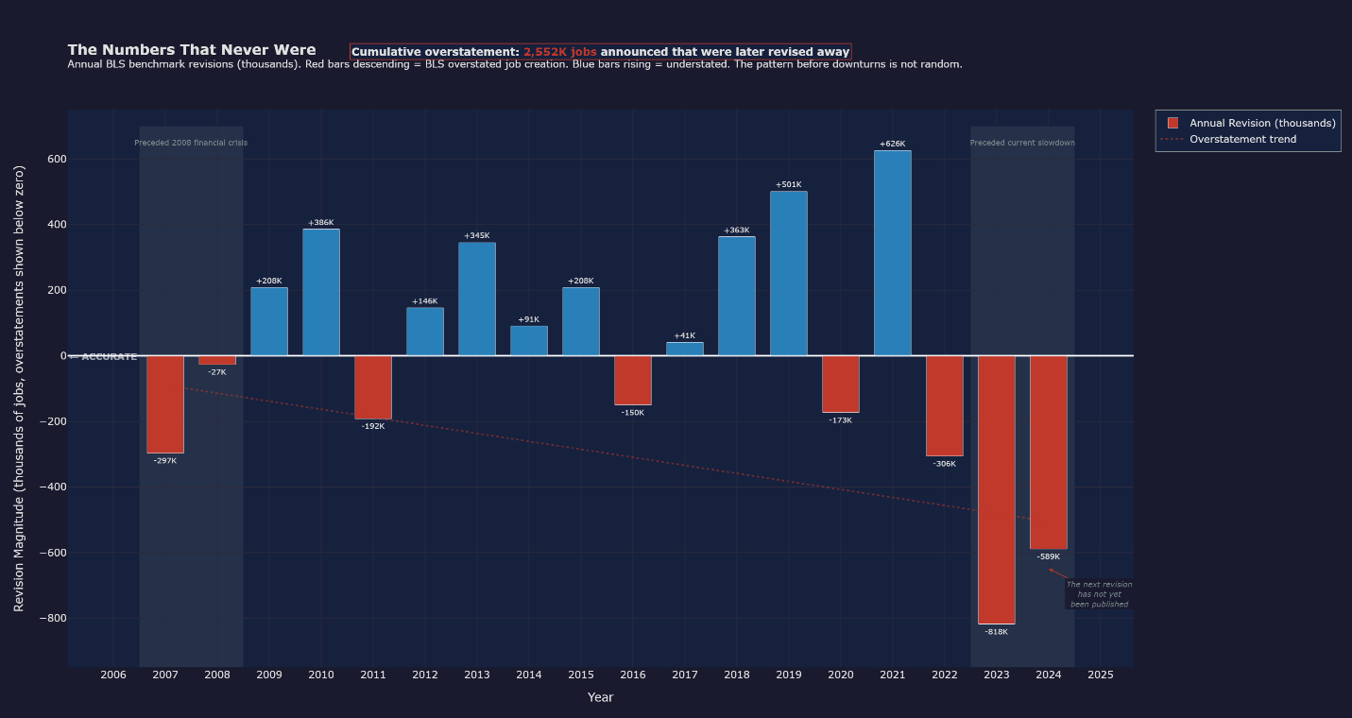
Figure 1. The Numbers That Never Were. Annual BLS benchmark revisions in thousands of jobs. Red bars descending below zero indicate overstatement of job creation and blue bars rising above zero indicate understatement. The largest red bars in the dataset appear immediately before the 2008 financial crisis and again in 2022 through 2024, where the BLS overstated job creation by a cumulative 2,552K jobs across three consecutive years. This is the largest sustained overstatement ever recorded in this series. The trend accumulation is not just that the latest numbers are the most negative. Its that the numbers on both ends of revision are growing at an increasing rate. This illustrates that the tools we have currently are becoming less and less accurate to represent the current state of the employment market.
Figure 2 illustrates the divergence between the BLS establishment survey and the household survey from 2006 through 2026. The blue line represents nonfarm payroll employment from the establishment survey and the red line represents civilian employment level from the household survey. The gold shaded region marks the post-2020 period of sustained divergence between the two measures.
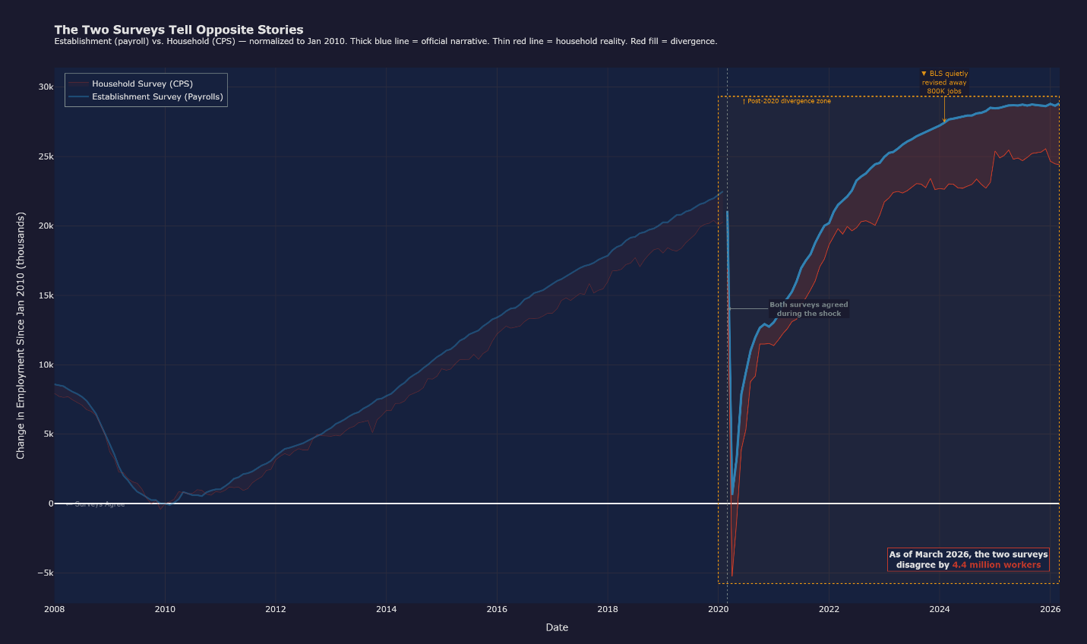
Figure 2.The Two Surveys Tell Opposite Stories. Two surveys designed to measure the same labor market have been telling increasingly different stories since 2020. The establishment survey counts payroll positions. The household survey counts employed people. When one person holds multiple part-time or contract positions simultaneously, the establishment survey records each position while the household survey records one employed person. The post-COVID shift toward gig work, remote freelancing, and multi-job arrangements inflates the payroll count without a corresponding increase in the number of employed individuals. The divergence is not noise. It is a structural artifact of measuring a labor market that changed form while the instruments remained fixed.
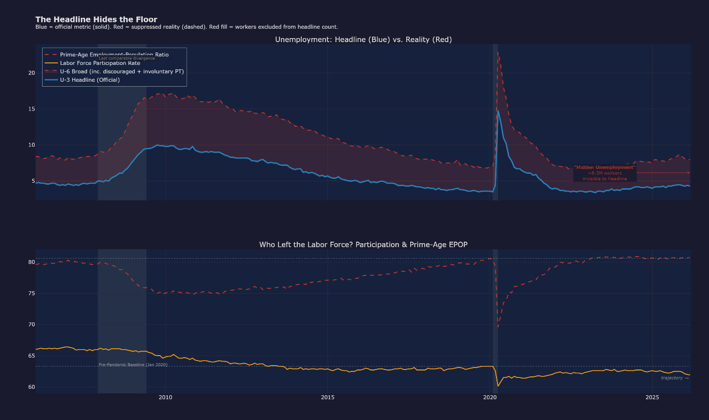
Figure 3 illustrates the divergence between the U-3 headline unemployment rate and the U-6 broad unemployment rate alongside the structural contraction of labor force participation and prime-age employment. The upper panel plots U-3 as a solid blue line against U-6 as a dashed red line, with the red fill between them representing the hidden unemployment population. The lower panel tracks the civilian labor force participation rate in orange and the prime-age employment-population ratio in dashed red, with the pre-pandemic baseline marked as a reference floor.
Figure 3. The Headline Hides the Floor. U-3 and U-6 show a huge measurable divergence. When converted to an absolute worker count, it shows about 6.3 million workers currently invisible to the headline figure. U-3 has returned to its pre-2008 range while U-6 has not even recovered post-COVID, The convergence is produced by discouraged workers exiting the measure entirely rather than by labor market recovery. The lower panel visualizes the consequence. Labor force participation has not recovered to its January 2020 baseline despite the five years of reported job growth, and the prime-age employment-population ratio tracks a continued downward trajectory rather than stabilization. The headline reports the rate, but the chart reports who has left left and did not come back.
Figure 4 shows the indexed growth of M2 money supply, the Federal Reserve balance sheet, the Consumer Price Index, and real median personal income from 2010 through 2026, with all series normalized to 100 at January 2010. A purchasing power line derived from the inverse of the Consumer Price Index is plotted on the same axis to show dollar erosion across the same window.
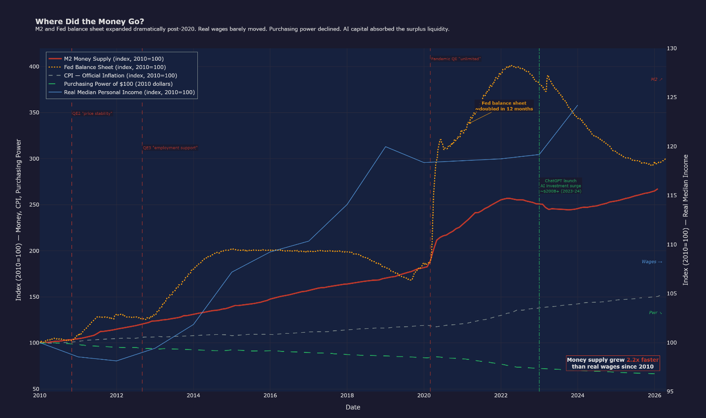
Figure 4. Where Did the Money Go? The Federal Reserve balance sheet doubled within twelve months following the pandemic QE expansion, reaching an index value above 400 relative to the 2010 baseline. M2 followed at index 265 by 2026. Real median personal income reached approximately 115 across the same sixteen years, a 15 percent cumulative gain against a monetary expansion exceeding 160 percent. Purchasing power declined continuously. The annotation marks the ChatGPT launch as the inflection point where surplus liquidity redirected into AI capital investment rather than wage compensation, with the chart noting an estimated $200 billion absorbed in 2023 through 2024. The money supply grew 2.2 times faster than real wages since 2010. The chart documents where the transmission mechanism broke. In plain terms, as monetary expansion increased the liquidity of U.S. dollars, The liquidity is mushed into markets and assets with the highest return value. This cause assets like real estate, equities, and AI stocks to rise in perceived value. As prices get translated down the value chain the consumer price index increases. This explains the diversion from wages to increases in common consumer goods. The decreases purchasing power in individuals not reaping the benefits from increase asset prices the harshest despite the fact the GDP is at an all-time high.
These trends in the market tell a coherent story. Covid specifically didn’t just break the employment market but made it illegible to agencies that read the data. We see divergences across the board in areas that should theoretically be highly correlated. We see greater revisions year to year in estimated growth. We see prices rise faster the wages should allow. We see discouraged workers dropping out of the market to enter field invisible to the BLS. We see consumers crying out because they are told time and time again, they live in a reality they can’t see or feel. We see price on common goods rise, the price of assets rise, all while Consumer sentiment fall to its lowest point ever recorded. Nothing invisible can be fixed. The change only starts once we start to illuminate the hidden.

Bureau of Labor Statistics. (2025). Current employment statistics: Benchmark revisions. U.S. Department of Labor. https://www.bls.gov/web/empsit/cesnaicsrev.htm
Federal Reserve Bank of St. Louis. (2025). Federal Reserve Economic Data (FRED). https://fred.stlouisfed.org
Fridman, L. (Host). (2024). Jeff Bezos: Amazon and Blue Origin [Audio podcast episode]. Lex Fridman Podcast. https://lexfridman.com/jeff-bezos/
Indeed Hiring Lab. (2025). Job postings on Indeed. Indeed. https://www.hiringlab.org
Lin, D., Wang, Y., Yang, Y., & Lan, X. (2026). Unveiling the visual rhetoric of persuasive cartography: A case study of the design of octopus maps. IEEE Transactions on Visualization and Computer Graphics, 32(1), 156–166. https://doi.org/10.1109/TVCG.2025.3634776
Prantl, V., Möller, T., & Koesten, L. (2026). Untangling rhetoric, pathos, and aesthetics in data visualization. IEEE Transactions on Visualization and Computer Graphics, 32(2), 2435–2453. https://doi.org/10.1109/TVCG.2025.3628181
University of Michigan. (2025). University of Michigan consumer sentiment index. Survey Research Center. https://data.sca.isr.umich.edu

